**Definition: Use vector mode to edit and customize vector shapes and design icons.**

**Solution:**

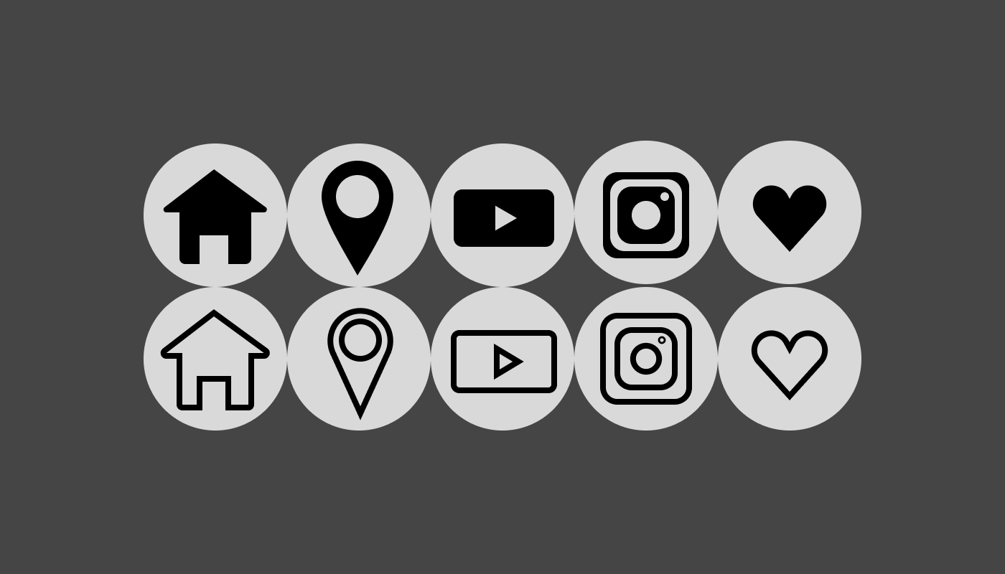

**Steps:**

* First Open Figma in browser mode.
* Then create the new document **File à New Figma Design.**
* Set the background colors **“#454545”** of frame.
* Take 10 ellipses of height=”**50 px**” and width=”**50 px**” and color=”**#FFFFFF**” to draw logos inside of them.
* **Steps for Filled Home Logo:**
  + Take the rectangle-1 for **wall** of height=”**20 px**” and width=”**25 px**” and fill color=”**#000000**”.
  + Take the rectangle-2 inside of rectangle-1 for door rectangle-2 height=”**10 px**” and width=”**10 px**” and fill color=”**#FFFFFF**”.
  + Take the polygon for ceiling of height=”**15 px**” and width=”**40 px**” and fill color=”**#000000**”.
* **Steps for Outline Home Logo:**
  + Take Pen tool to draw outline Home Logo of width=”**40 px**” and height=”**35 px**”.
* **Steps for Filled Location Logo:**
  + Take an ellipse for height=”**40 px”**, width=”**25 px**” and fill color=”**#000000**”.
  + Take another ellipse of width**=”15 px”** and height**=”15 px”** inside of previous one.
* **Steps for Outline Location Logo:**
  + Take an ellipse for height=”**40 px”**, width=”**25 px**”, stroke=”**2 px**” and give opacity=”**0%**”.
  + Take another ellipse of width**=”15 px”,** height**=”15 px”**, stroke=”**2 px**” and opacity=”**0%**” inside of previous one.
* **Steps for Filled YouTube Logo:**
  + Take a rectangle of height=”**20 px”**, width=”**35 px**”, color=”**#000000**”, corner radius=”**3**”.
  + Take the polygon for height=”**10 px**”, width=”**10 px**”, rotation=”**-90°”** and fill color=”**#FFFFFF**”.
* **Steps for Outline YouTube Logo:**
  + Take a rectangle of height=”**20 px”**, width=”**35 px**”, corner radius=”**3**”, stroke=”**2 px**” and give opacity=”**0%**”.
  + Take the polygon for height=”**10 px**”, width=”**10 px**”, rotation=”**-90°”**, stroke=”**2 px**” and give opacity=”**0%**”.
* **Steps for Filled Instagram Logo:**
  + Take rectangle-1 of height=”**30 px”**, width=”**30 px**”, color=”**#000000**”, corner radius=”**5**”.
  + Take rectangle-2 inside of ractangle-1 with height=”**25 px”**, width=”**25 px**”, color=”**#FFFFFF**”, corner radius=”**5**”.
  + Take rectangle-3 inside of ractangle-2 with height=”**20 px”**, width=”**20 px**”, color=”**#000000**”, corner radius=”**5**”.
  + Now inside of rectangle-3 take an ellipse of height=”**10 px”**, width=”**10 px**”, color=”**#FFFFFF**”.
  + Take another ellipse of height=”**3 px”**, width=”**3 px**”, color=”**#FFFFFF**” to draw white dote on the top-right corner of rectangle-3
* **Steps for Outline Instagram Logo:**
  + Take rectangle-1 of height=”**30 px”**, width=”**30 px**”, corner radius=”**5**”, stroke=”**2 px**” and give opacity=”**0%**”.
  + Take rectangle-2 inside of ractangle-1 with height=”**25 px”**, width=”**25 px**”, corner radius=”**5**”, stroke=”**2 px**” and give opacity=”**0%**”.
  + Take rectangle-3 inside of ractangle-2 with height=”**20 px”**, width=”**20 px**”, corner radius=”**5**”, stroke=”**2 px**” and give opacity=”**0%**”.
  + Now inside of rectangle-3 take an ellipse of height=”**10 px”**, width=”**10 px**”, stroke=”**2 px**” and give opacity=”**0%**”.
  + Take another ellipse of height=”**3 px”**, width=”**3 px**”, stroke=”**1 px**” and give opacity=”**0%**” to draw white dote on the top-right corner of rectangle-3
* **Steps for Filled Like Button:**
  + Take Pen tool to draw outline Like button of width=”**30 px**”, height=”**20 px**” and fill color**=”#000000**”.
* **Steps for Outline Like Button:**
  + Take Pen tool to draw outline Like button of width=”**40 px**”, height=”**35 px**” and stroke=”**2 px**”.
* Now, Go to the **Export** button in the property panel. And **Export** it with .**JPG/.PNG** format.